Title: Money supply – Interest rates – Exchange rates
Subject: Macro 3

1. Money  A. Properties  B. Definitions  2. CB B/S  3. Demand for money  A. Assumptions  B. Aggregate Demand for money  C. Equilibrium  D. Shifts  a. Changes in money supply  c. Changes in output  4. Linking money and exchange rates in the SR  A. Shifts in money supply  5. Linking money and exchange rates in the LR  A. Defining the long run  B. Money and the exchange rate in the long run | Properties of money  i. Medium of exchange: eliminates inefficiency of barter  ii. Unit of account: all prices are quoted as number of units of currency, relative prices in parter are potentially htousands  iii. Store of value: can be used to transfer purchasing power from the present to the future, i.e. it is an asset. Nobody would accept it if its value in terms of goods and services evaporated rapidly (high inflation).  We shifted from gold backed money to fiat money. Now money is also the most liquid of assets.  Various definitions of money, depending on the asset included, its liquidity etc.  In order of liquidity:  - M1 includes currency and demand deposits (the most liquid deposits) and, since April 2020, savings deposits (due to deregulation they are now more liquid in the Us). This is what we define money, we assume i = 0.  - M2 includes time deposits and MMM Funds shares.  B/S  i. “Foreign assets”: mainly foreign bonds (+ gold). Make up the CB’s official international reserves.  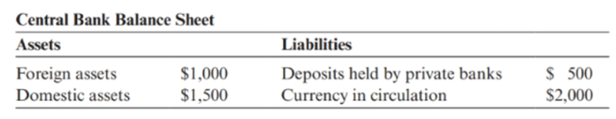  ii. “Domestic assets”: Think of it as mostly gov bonds  iii. “Deposits held by domestic banks”: Private Banks hold required and excess reserves in CB  iv. “Currency in circulation”: coins and banknotes.  CB vs Private banks B/S  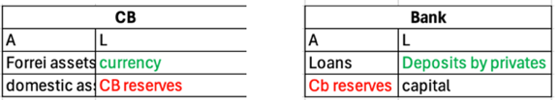  Money supply (MS): deposits at commercial banls+ currency  Monetary base (MB): currency + reserves <-- CB controls Monetary base, this is what we will call M in our models  MS = μ * MB, where μ is the money multiplies  How an OMO works:  CB buys a domestic assset from Us bank and pays with reserves. COMPRA BOND=>ESPANDI LIABILITIES => IRRORA LIQUIDIT  CB Domestic assets $↑$, CB reserves $↑$=> MB increases --> MS increases by dMS * μ  Logic: the purchase expands the monetary base because the CB pays for its purchase of assets by issuing liabilities. Instead if assets are sold by the Cb and money is paid in exchange thin that cash is retired from circulation  i. money = m1 and i = 0. Bonds offer a positive interest rate (less liquid).  ii. Assume deposits perfectly insured and no default risk for bonds, still big risk: inflation affects money and government bonds equally  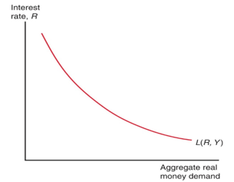  Aggregate demand for money depends:  i. Negatively on the nominal interest rate (The higher return on bonds the higher demand for bonds, the lower demand for money )  ii. Positively on (and in direct proportion to) the price level. If the price level increases by 10% (inflation = 10%), households and firms must use 10 % more money to purchase the same typical basket of goods and services  iii. Positively on real GNP. When real GNP increases, more goods and services are purchased and sold in the economy(More transactions = more demand for money)  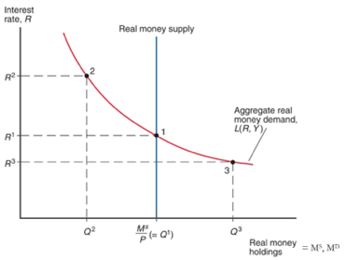  Equilibrium (thanks to arbitrage)  Arbitrage:  Point 2: Excess supply of money. Everybody tries to get rid of money and buy Gov. bonds => the price of bonds increases and their yield declines until we reach the equilibrium  Point 3: Excess demand for money. Everybody tries to get rid of bonds in exchange for money => the price of bonds falls and their yield increases until we reach the equilibrium  I. The effects of a change in money supply  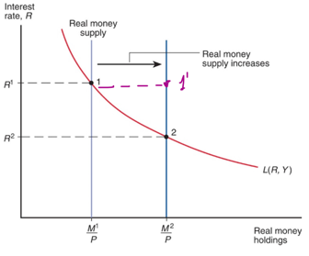  II. The effects of a change in output / real income on interest rates  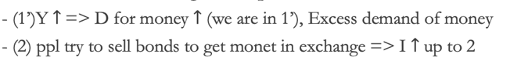  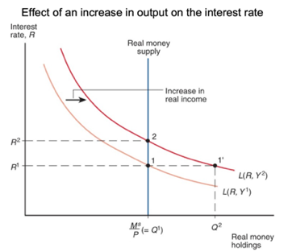  Linking Money-rates to exchange rates (the graph in the bottom is the upper graph rotated )  A. Assuming Price level and expected exchange rate are fixed  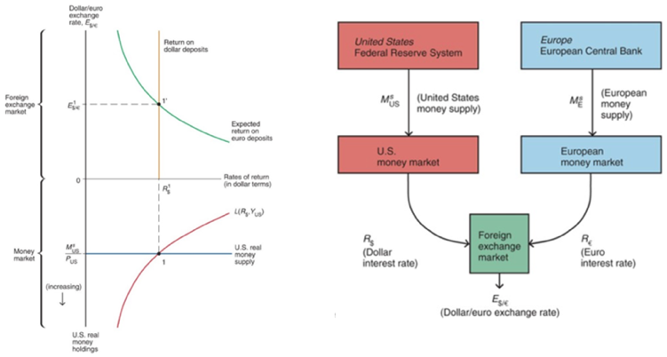  ****If prices do not change the expected exchange rate cannot change  Key result: an increase in a country’s money supply (decline in its interest rate) causes its currency to depreciate  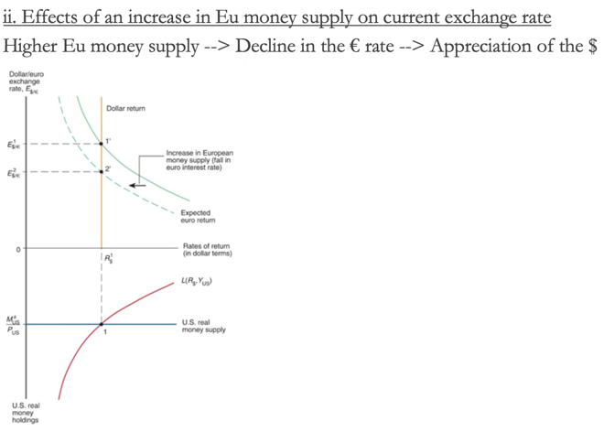  YOU HAVE ALREADY SEEN THIS IN THE GRAPH TOP OF THE PAGE!  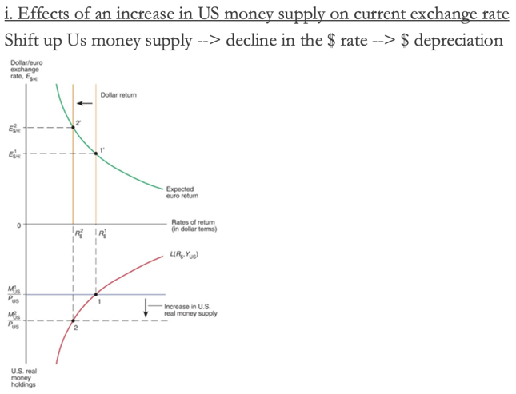  The Long Run  i. Idea  LR: equilibrium that would occur if no new shocks and all prices (including wages) were perfectly flexible so at to ensure the full employment of all factors, including labor and capital. Output is at $\overline{ y}$ and interest rate $\overline{r}$, price level and expected exchange rate are not fixed => M^{S} = P * L ($\overline{ Y}$, $\overline{R}$ )  ii. Neutrality of money in the LR  If prices double also M^{S} will double, but output and interest level will be at the same level. A permanent increase in money supply by × percent causes an increase in the price level by the same proportion, × percent, $\frac{dM}{M}= \frac{dP}{P}$. Example (real): Fra new currency (k): k = l/100 => both Ms and prices are divided by 100. => Franc example all else equal  With fixed prices a huge decline in Ms would create strong decline in output.  iii. Economic intuition  Economic intuition: the demand for money is demand for real money holdings. If its determinants are fixed at their long run levels, real money demand does not change when money supply increase. Therefore, real money supply must not increase either. This can happen only if the price level increases in the same proportion as nominal money supply.  Money and the exchange rate in the long run  So a recuction of k% in M^{S} (- 50%, every two pair of old dollars are converted to one dollar) = reduction of k% in domestic prices  Next step: appreciaiton 50% of the dollar to euro exchange rate = domestic price of foreign currency $↓$  => Hence, overall: if you decrease money supply by 10% your exchange rate will appreciate by 10%  Ex. Money supply – 50% = prices – 50% => dollar to euro from 1.20 to 0.60., p have decreased by 50% => relative prices unchanged (relative prices of Eu to US: $\frac{Es/€P*}{P}$)  However, the exchange rate does not depreciate immediately to the LR value. Initially, the ST exchange rate overshoots its LT level:  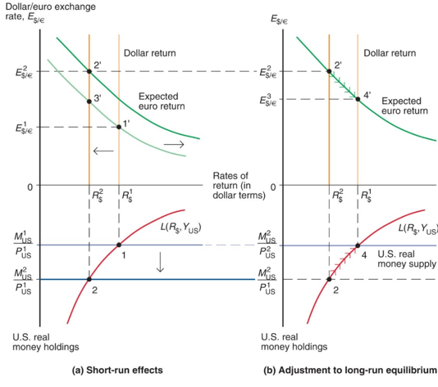  SR (sticky prices):  i. M^{S} increases by 50% => interest reates decrease  ii. Hence this make E$/€ increase AND, in this case, being the expected exchange rate not anchored, $E_{\$/€}^{e}$ increases by 50%  iii. Now, by UIP, the current exchange rate must be expected to appreciate. However, it will not appreciate back to the initial level but to a more depreciatd level. Hence, In order to have an appreciation to satisfy UIP we need the exchange to depreciate now more than in the LR.  Note: SR flexible prices is differet to SR fixed prices, bc there is the increase in $E_{\$/€}^{e}$  There would have been no change in real money supply if prices were sticky  LR:  i. P progressively increases to 50% => final real money supply converges to the initial one = interest rate goes back to initial point (from 2 to 4)  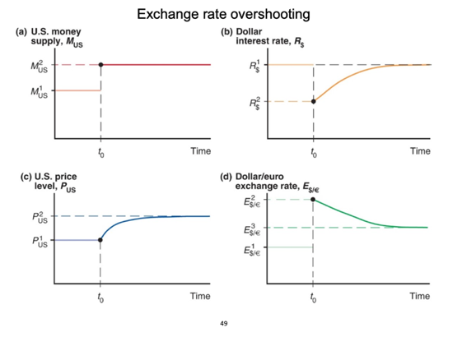  ii. as the interest rate increases the dollar appreciates. In final equilibrium (point 4’) dollar / euro exchange rate is more depreciated than at its original equilibrium in point 1: exchange rate has depreciated in same proportion as increase in money supply.  The green courve does not shift back bc in the LR there is no revision in the expected rate  Final RER converges back to initial one.  So, initially, the currenct exchange rate had reached a level 2’ higher than the final equilibrium 3’, overshooting the finsl lt value.  *Overshooting and price rigidities  Exchange rate overshooting is a consequence of price rigidity (stickiness) that causes money supply to increase and therefore dollar interest rate to fall initially. If they were flexible immediate 10% depreciation: If there were complete price flexibility, price level would increase immediately in proportion to money supply increased and there would be no initial increase in money supply, no initial decline in dollar interest rates, and no need for exchange rate overshooting  Note: real money supply asymptotically reaches the initial level  RER  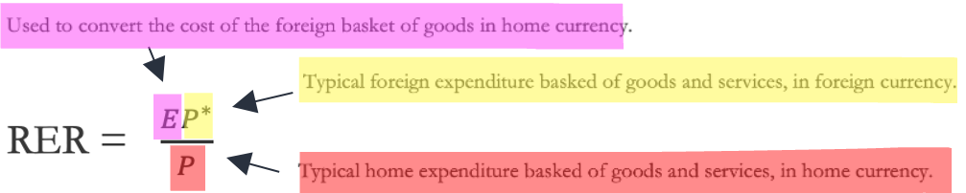  => RER is the relative price of foreign output in terms of domestic ourput  Ex. E = 1.10 $/€, Eu basket = 40€, US basket = 50$ => RER = 0.88 price of Eu basket in terms of Eu basket = 0.88 Us baskets / Eu Basket  Before we had converted the cost of goods in rel prices. This is an aggregate level conversion on bundle of goods representing the full econ.  *In a FE regimse the nominal exchange rate does not depreciate nor appreciate. But you can account for changes in prices through the RER.

